**Observations from looking at the PyCity Schools.**

1. **Individual Math and Reading Scores.**

*Across the 15 schools the students in Grade 9 thru Grade 12 are performing uniformly. There is not much improvement nor there is deterioration. The difference is between grades is >= 1% in most cases. This makes me wonder if the results have been skewed just for reporting purposes. One more observation is that the students in most of the schools are performing better in Reading than in Math.*

1. ***Charter VS District***

*The students in the Charter schools are preforming better than Students belonging to the District Schools. The students tend to perform better in both Math and Reading than students present in District Schools. It appears that student to Teacher Ratio is correct. All the Charter schools (except one) have less than students 2000. In comparison the District schools have more students and as a result the student’s performance in Math and Reading is being affected. The Teacher to Student Ratio is one of the root causes for students not performing well.*

1. ***Budget.*** *This is not a factor in driving Students performance. Even though the budget allocated for each student in District schools is more than the one allocated to the Students in Charter Schools the Students in Charter school are performing much better than the students in District schools.*

***Recommendation:***

1. *Implement the model being followed in Charter schools in District Schools. One thing to be looked into is Student to Teacher Ratio in District Schools.*
2. *The District on the whole needs to work on the Math and Reading scores. With scores from the 15 schools it does not appear that this district has a A++ Rating.*

***Exhibit A – Charter Schools.***

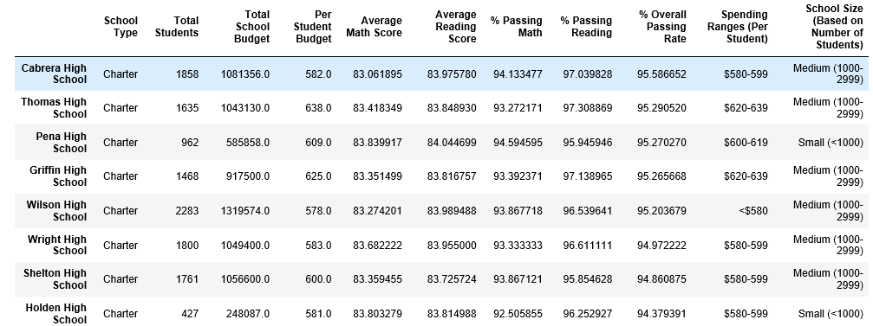

***Exhibit B – District Schools.***



